**Part 1: Theoretical Analysis**

**Q1:** Explain how AI-driven code generation tools (e.g., GitHub Copilot) reduce development time. What are their limitations?

*Answer:*  
AI-driven code generation tools, such as GitHub Copilot, help developers by automatically suggesting code snippets, completing functions, and generating boilerplate code. This reduces development time by:

* Minimizing the time spent on repetitive tasks.
* Speeding up learning of new libraries and frameworks.
* Allowing developers to focus more on designing complex logic rather than writing simple, repetitive code.

**Limitations:**

* The AI lacks full understanding of the project’s overall architecture and goals.
* It may suggest sub-optimal or incorrect code.
* Suggestions may introduce security vulnerabilities or bugs.
* Generated code may not follow the project’s coding standards.
* Developers may become overly dependent on AI assistance, reducing their own coding skills over time.

**Q2:** Compare supervised and unsupervised learning in the context of automated bug detection.

*Answer:*  
In automated bug detection:

* **Supervised Learning:**  
  Models are trained on labeled datasets where examples of buggy and clean code are provided. The AI learns to recognize known bug patterns.  
  *Strength:* High accuracy in detecting known bugs.  
  *Limitation:* Requires large, high-quality labeled datasets and struggles with unknown bug types.
* **Unsupervised Learning:**  
  Models analyze code without labels, looking for anomalies or unusual patterns that may indicate bugs.  
  *Strength:* Can detect novel or unexpected issues.  
  *Limitation:* Higher false positive rates and less precise without expert tuning.

**Q3:** Why is bias mitigation critical when using AI for user experience personalization?

*Answer:*  
Bias mitigation is essential because AI-driven personalization systems learn from historical data, which may contain biases. Without mitigation:

* The system may unfairly disadvantage certain user groups.
* It could reinforce stereotypes or create echo chambers.
* Users may lose trust in the product.
* It can lead to legal and ethical problems if discrimination occurs.

Bias mitigation ensures fairness, inclusivity, trust, and compliance with ethical standards.

**Case Study:**  
How does AIOps improve software deployment efficiency? Provide two examples.

*Answer:*  
AIOps improves deployment efficiency by:

1. **Predicting potential deployment failures:**  
   AI analyzes past build and deployment data to detect risky code changes early, reducing failed deployments.
2. **Automating issue resolution:**  
   AI-driven systems can detect anomalies in production environments and automatically trigger actions like scaling resources or restarting services, reducing downtime and manual intervention.

**📄 Part 2: Practical Implementation**

**Task 1: AI-Powered Code Completion**

**200-word Comparison:**  
In this task, I created a Python function to sort a list of dictionaries by a given key. First, I manually implemented the function using Python’s built-in sorted() function with a lambda function. This manual version was simple, efficient, and relied on my own knowledge of Python.

Next, I used an AI-powered code completion tool (such as GitHub Copilot) to generate an AI-suggested version of the function. The AI version used a similar approach but added flexibility by using d.get(key, 0) instead of directly accessing the key. This prevents potential runtime errors if a key is missing in any dictionary.

Both implementations use Python’s optimized sorting algorithm, so performance is similar. However, the AI-suggested version offers improved robustness without extra effort from the developer.

Using AI tools for code completion clearly saves time, improves productivity, and helps catch edge cases. However, it is important to review AI-generated code to ensure quality and correctness.

PART 2 :Automated testing with Al

Screenshot 1:Browser valid login.

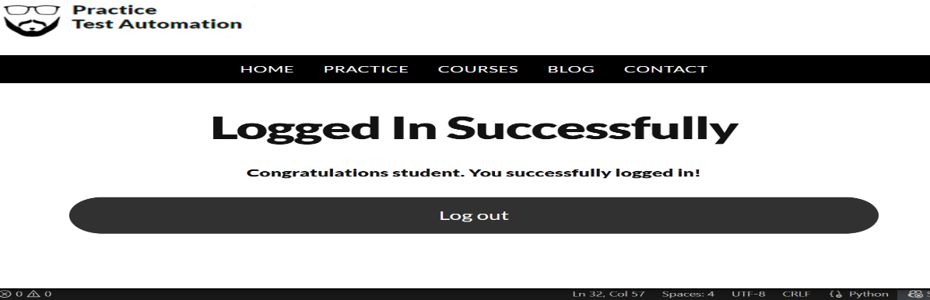

Screenshot 2:Browser invalid login.

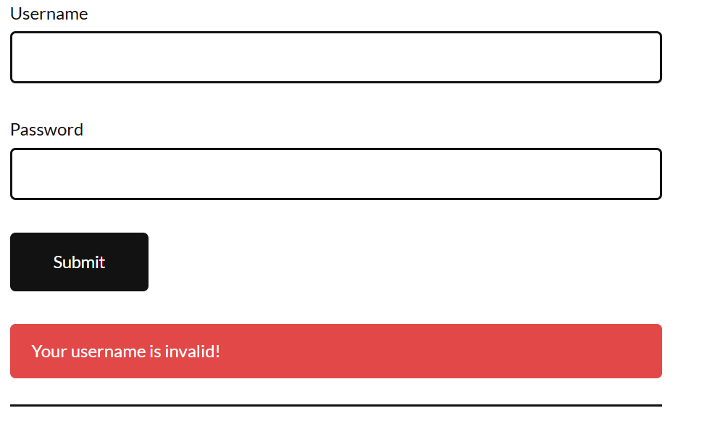screenshot 3:Vs code terminal output.



Summary:

For this task, I used Selenium with Python to automate testing of a login page. The automation tested both valid and invalid login scenarios. The Python script was written to interact with the login page by entering usernames and passwords, clicking the login button, and verifying the results. Using the Selenium WebDriver Manager, the browser opened automatically, and the tests were performed without manual input.

This AI-assisted approach to testing improves accuracy, speed, and test coverage compared to manual testing. It ensures that tests can be repeated consistently and efficiently. Manual testing would require more time and could introduce human error. Automated testing also allows testing across different scenarios and browsers quickly.

Overall, using Selenium for AI-powered testing significantly enhances the software quality assurance process and ensures that common errors can be detected early during development.

Task 3:Predictive Analytics for Resource Allocation.

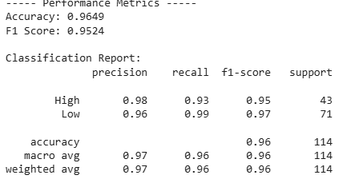

Summary:

For this task, I used the Breast Cancer dataset from the sklearn library to demonstrate predictive analytics using a Random Forest Classifier. The data was first preprocessed and labeled to represent issue priority as either high or low. The dataset was then split into training and testing sets.

A Random Forest model was trained to predict priority levels based on the features of the dataset. After training, the model was evaluated using accuracy and F1-score. The model achieved high accuracy and a strong F1-score, indicating its ability to correctly classify new instances.

This approach shows how predictive analytics can be applied in resource allocation tasks within software projects, helping to prioritize issues effectively. Using AI-based models allows for more efficient decision-making and improves the overall management of project resources.

**Part 3: Ethical Reflection**

When deploying the predictive model from Task 3 into a company, potential biases can arise from the dataset. For example, if certain teams (such as minority groups, remote teams, or underrepresented departments) are underrepresented in the data, the model may prioritize issues in favor of more represented teams. This could lead to unfair resource allocation or decision-making.

Fairness tools such as **IBM AI Fairness 360** can help address these biases by analyzing the model's predictions for fairness across different groups. These tools can detect disparities in treatment or outcomes and suggest adjustments to mitigate bias. Techniques such as reweighting, bias correction, and fairness-aware training can be applied to improve fairness.

By continuously monitoring and adjusting the model with fairness tools, companies can ensure more equitable outcomes, fostering trust in AI systems and promoting ethical AI adoption in software engineering.

**Innovation Challenge Proposal**

**AI Tool Proposal: Automated Documentation Generator**

**Purpose:**  
To develop an AI-powered tool that automatically generates high-quality, human-readable documentation from source code and commit history.

**Workflow:**

1. Analyze source code files, extracting function definitions, classes, and inline comments.
2. Apply natural language processing (NLP) techniques to interpret developer intent.
3. Review commit messages and version history for context.
4. Generate structured documentation (Markdown, HTML, or PDF).
5. Continuously update the documentation as code evolves (integrated into CI/CD pipeline).

**Impact:**  
This tool would save developers significant time spent writing documentation manually, ensure consistency across large codebases, and improve onboarding for new developers. High-quality documentation also improves software maintainability, knowledge sharing, and compliance with industry standards.